T3/4 HVAC controller direct

Coms cable

The intent of this cable is to bypass all unit and car wiring to establish a serial connection with the controller. This cable also works on the bench to test, load and check firmware on the controller.

Parts

1. Male DB9 connector
   1. Trimet part number xxxxxxxxxx
2. Serial DB9 connector body clamshell
   1. Trimet pn xxxxxxxxx
   2. Digikey pn xxxxxxxxx
3. DB9 connector male pins
   1. Trimet part number
4. Wire
5. 3pin board connector
   1. Trimet pn 285-3132X
   2. Wago
   3. TK pn 41-3934

Assembly

1. Put it togeather

Pinout

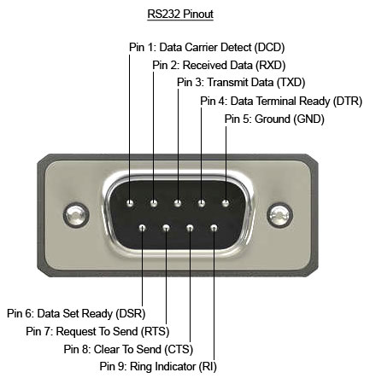DB9 wire wago

2 tx/rx 3?

5 gnd 2

3 rt/tx 1